

Estonia / Eesti, report – 2016
Membership
In 2015, the Estonian Music Library Association (EMLA) had 13 members of which 10 were institutional and 3 individual. There were no changes to membership during the last year.
The Board also comprised the same members: Kaie Viigipuu-Kreintaal (President, Tallinn Central Library, TCL), Ilvi Rauna (Vice-President, Estonian Academy of Music and Theatre Library, EAMTL), Heidi Heinmaa (Secretary, National Library of Estonia, NLE), Avo Kartul (University of Tartu Library, UTL), Ene Roost (Pärnu Central Library), Meery Salu (Tartu Public Library), and Viive Valper (Estonian Philharmonic Chamber Choir).
The Board had a meeting on 10 February at the Tallinn Central Library. Current issues were resolved via e-communication.
The Annual Meeting was held on 24 April at the National Library of Estonia.
25 participants attended the meeting including representatives from nine institutions and one individual member.
EMLA as an institution is a member of the Estonian Music Council and the Estonian Music Information Centre.
Activities
Meetings
Traditionally, our Spring Seminar takes place on the same day as the Annual Meeting. This year's seminar theme was “From Delta Blues to British Blues: Some Snapshots of the History of the Blues”. The presenter was our dear colleague Andres Roots, the music librarian of the Tartu University Library. Andres Roots is one of Estonia's best known blues guitarists in the world. Roots has played in the band Bullfrog Brown. Since 2015 he has been a member of a group called Andres Roots Roundabout (www.andresroots.com).
The 20th Anniversary Conference of The Music Department of Pärnu Central Library was held on 9 October.
The main topics of the conference were: "An overview of the IAML congress in New York" (Katre Riisalu and Heidi Heinmaa, NLE); „20 years in the music department” (head of department Ene Roost, Pärnu Central Library); „Fragments of the history of musical life in Pärnu“ (Gerly Kättmann and Kristiina Kiis, Estonian Theatre and Music Museum). The conference ended with a spirited workshop "How to teach singing?" and communal singing led by choral conductor Toomas Voll.
Other Activities
Copyright
Dealing with the problem of lending video recordings also continued this year. Estonian libraries still cannot lend video recordings without the permission of the producer, but getting licenses is really complicated for libraries.
The process of amending the Copyright Act in Estonia is still ongoing. In 2015, forced by film producers, the draft law was changed so that films produced in Estonia could be loaned freely seven years after the start of distribution in Estonia. Such a long embargo period seems absurd and unwarranted. At the same time foreign films could be loaned only under a license. Our aim is that video recordings could be loaned in the same way as books, CDs or sheet music and the copyright holders could get remuneration for it. EMLA (with the Librarians Association and directors of central libraries) sent the application to the Ministry of Justice, Ministry of Culture and the parliament's culture committee members with the proposal to replace a 7-year embargo period with a maximum one-year period. We feel that the current law - as well as the draft law - ignores public interest by restricting free access to the collection bought with taxpayers' money: audiovisual heritage is not accessible to all on an equal footing merely due to the medium of the carrier.
We received an answer from the Ministry of Justice that our views have been noted but there were no developments on this issue during the second half of the year.
Year of Music in Estonia
2015 was the Year of Music in Estonia. The motto of the Year of Music was “Sounds good!” and it aimed to put Estonian multifaceted musical life under the spotlight, introducing creators and performers of music, promoting interest towards music and increasing the role of music in people’s lives.
As it was the Year of Music, music libraries took the opportunity to promote themselves more than usual. A lot of music related events, exhibitions, etc. were organised in libraries. Music librarians introduced their work to colleagues from other departments and more user training was organised.
During the year at least one article regarding music librarianship was published in each issue of our one and only professional journal “Raamatukogu” (”Library”). The articles concerning music libraries were also published in other publications. For example several articles about the 20th anniversary of the Music Department of Pärnu Central Library event were published in the local newspaper. It is also worth highlighting that the head of the music department, Ene Roost, was voted Woman of the Year in Pärnu.
Participation in international events and issues
The RILM Estonian National Committee includes representatives of NLE and EAMTL (coordinator Heidi Heinmaa). This year 73 entries with English annotations of music literature published in Estonia were added to the RILM database.
IAML's annual congress in New York was attended by Katre Riisalu and Heidi Heinmaa (NLE). Heidi gave a presentation "Digital resources in Estonian archives and libraries that further music research".
The BAAC’s conference "Echoes of the Past, Insights to the Future" in Tallinn was attended by Marika Koha, Rena Tüür and Kaja Loel (NLE), Maarja Leemet and Ilvi Rauna (EAMTL).
Kaie Viigipuu-Kreintaal
President, IAML (Estonia)
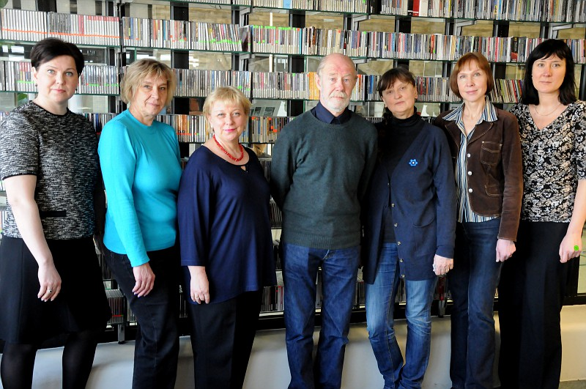
The Board of Estonian Branch in Annual Meeting 24.04.2015. Kaie-Viigipuu-Kreintaal, Meery Salu, Ene Roost, Avo Kartul, Viive Valper, Heidi Heinmaa, Ilvi Rauna
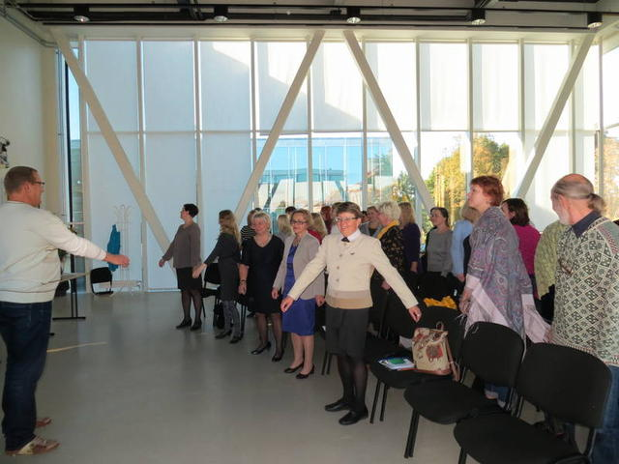 | 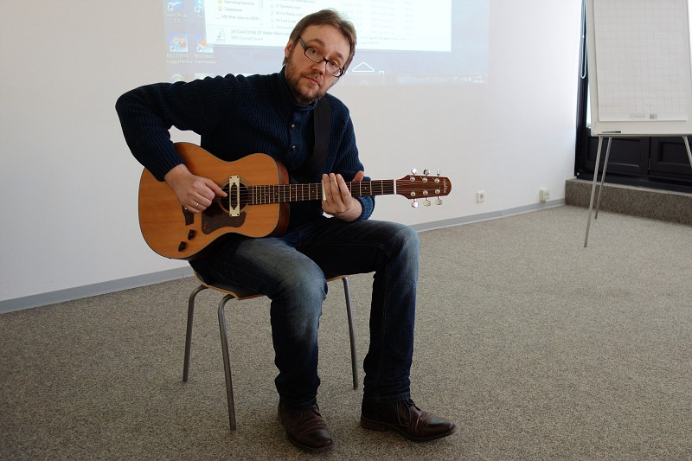
Workshop How to teach singing by Toomas Voll in Pärnu 09.10.2015 | Andres Roots as a lecturer of Spring Seminar 24.04.2015

