

Spain – 2016

The Board of Aedom remained the same as in 2014:

* Reynaldo Fernández Manzano, President
* Antonia Riquelme Gómez, Vice President
* Cristina Martí Martínez, Secretary
* Nekane Mazurka Salsamendi, Treasurer
* Jorge García, Former President

Committees and working groups active during 2015 were:

* Sound recordings
* Symphonic orchestras' archives
* Musical iconography
* Access to Music Archive (AMA)

The committee “Music schools and conservatories libraries” was revived in 2015 after a period of inactivity. They will develop new projects in 2016.

In 2015, our annual meeting was held in Barcelona, at the Library of Catalonia, on Saturday March 21st. As usual, the day before, Friday the 20th, commissions and working groups also met in the same venue.

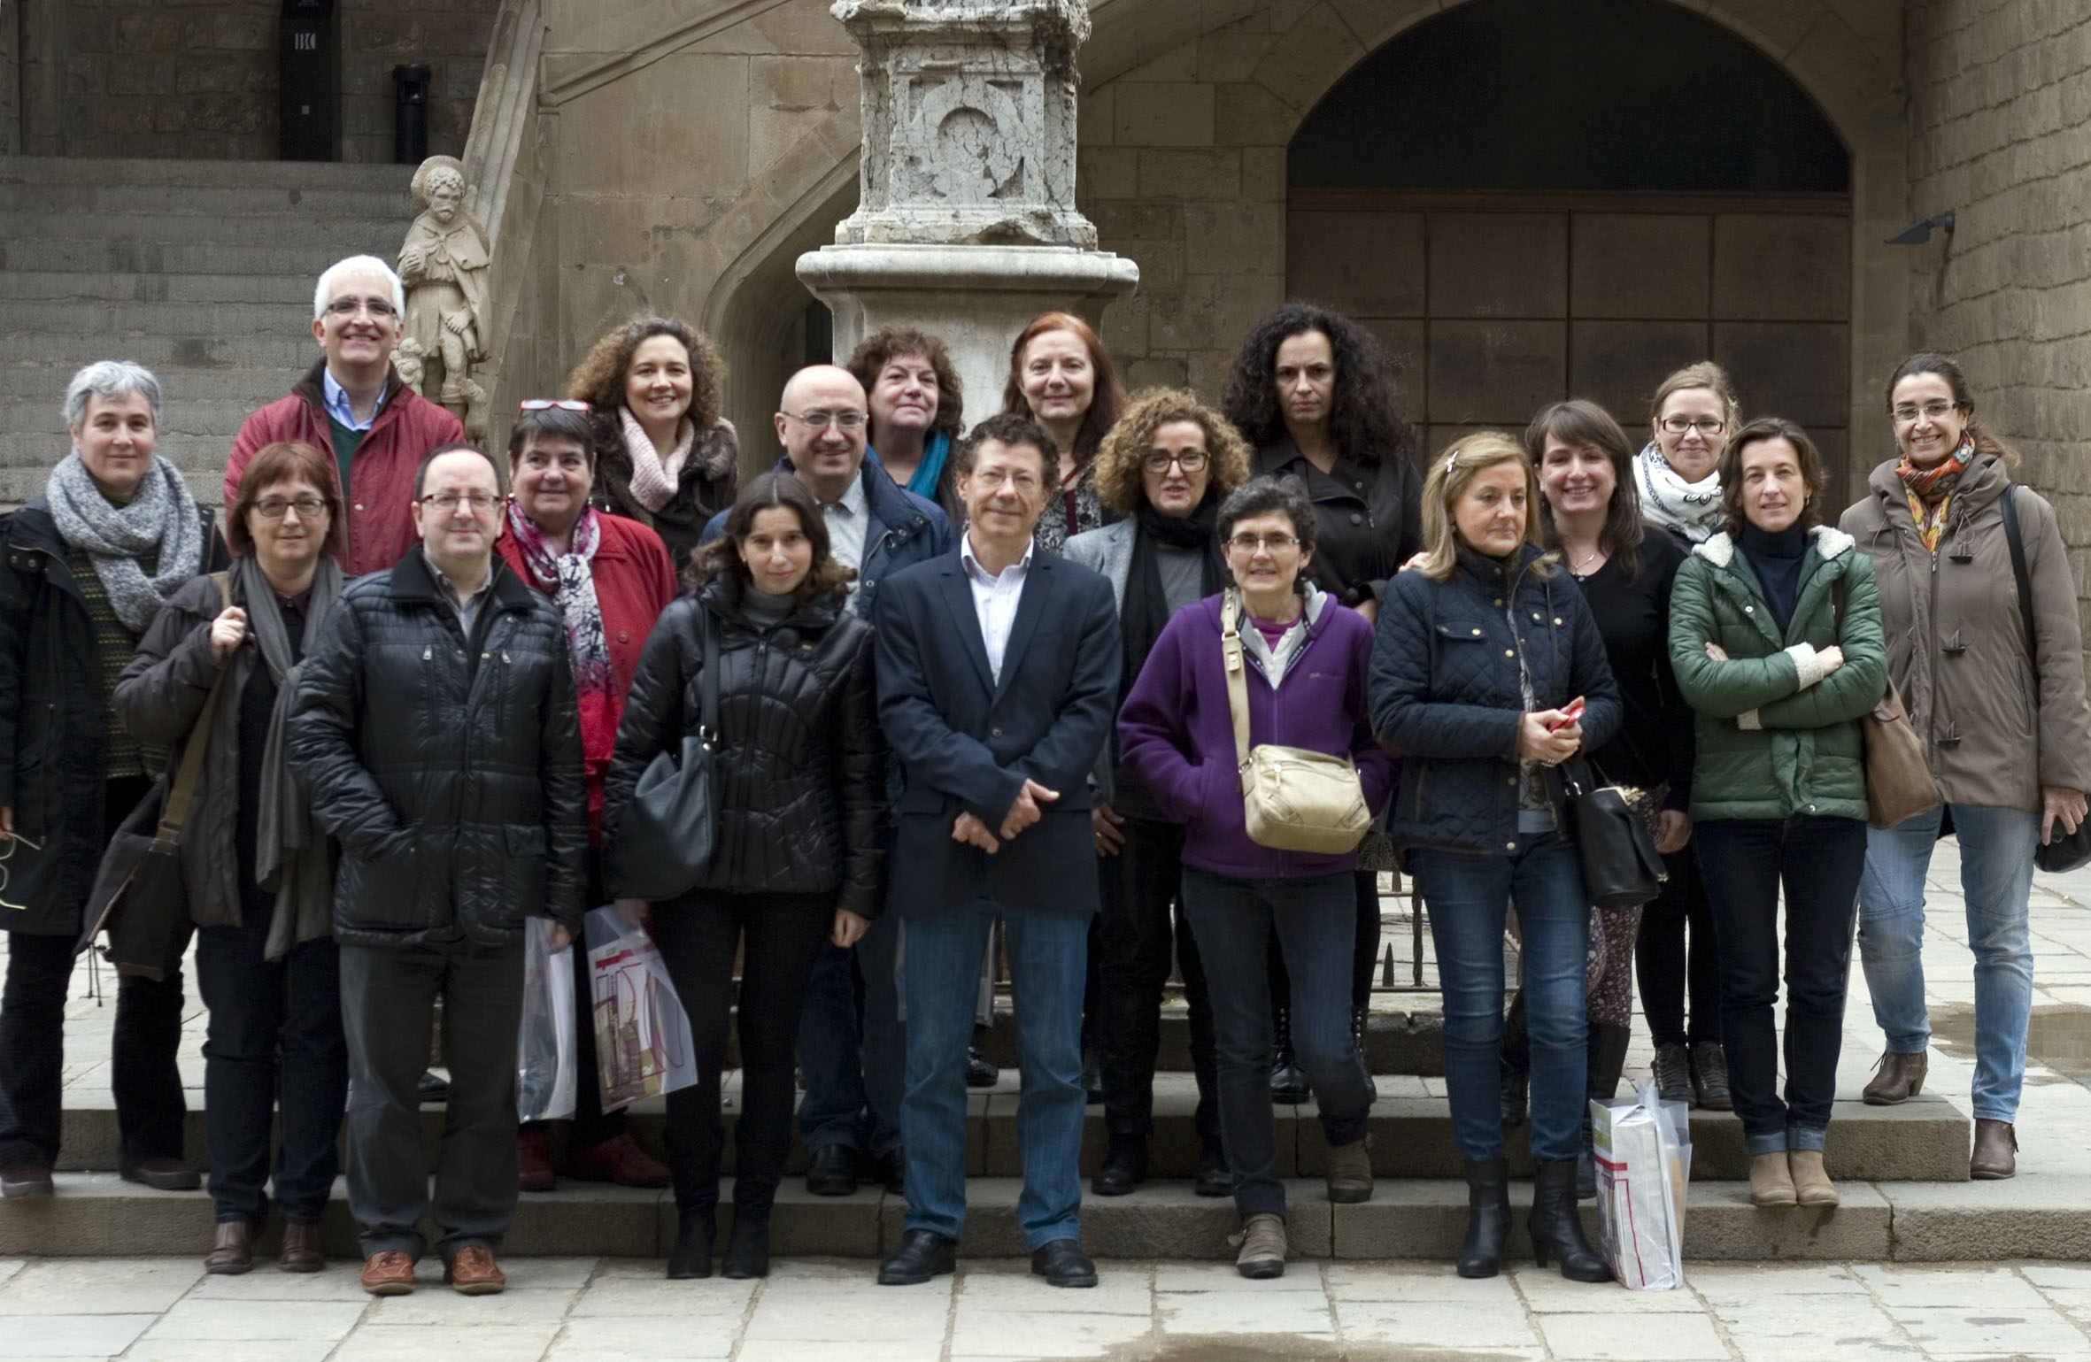

Some of the people attending the meeting

Also on the afternoon of the 20th, partners had the opportunity to take a tour of the Library of Catalonia; Eulàlia Barbosa Baladas, from the Unitat de Sonors i Audiovisuals, was the guide for the visit. There was also a visit to the exhibition "Daniel Blanxart, la passió per la música" which describes the record collection, piano rolls and catalogues belonging to the engineer Daniel Blanxart; Margarida Ullate I Estanyol, director of the Unitat de Sonors i Audiovisuals and curator of the exhibition, guided the visit.

During the meeting the attendees heard reports on the activities of the association during the year: providing scientific standards and a new editorial committee to our journal Boletín DM, converting its historical archive to digital, and making it available internationally, online; updating our website and all our databases; establishing relations with the archives of the Catholic Church with the idea of including them in the AMA project, Access to Music Archives.

At the meeting new projects and activities to be carried out throughout the year were raised. Some of them were: implementation of OJS (Open Journal System), publication of the Boletín DM, sending our publications to Latin American libraries, improvements in all three databases, and development and maintenance of the website.

In 2015, we had 147 members: 82 institutions and 65 individuals, just two members more than the previous year. The number of institutional partners increases and the number of individual members decreases. We also have four reduced-fee partners, which means they are not part of IAML, they just belong to Aedom.

Working groups

The Musical Iconography working group made several improvements in its database (<http://iconografia.aedom.org/>), and presented it in New York during the IAML / IMS Congress: "Music Research in the Digital Age", where it received excellent reviews from fellow professionals.

The database "Atril" (<http://atril.aedom.org/>), which contains information on Spanish symphonic music, has been enriched in 2015 with information on Andalusian symphonic works. This has been possible thanks to an agreement signed with the General Society of Authors in Andalusia

Matriz (<http://www.aedom.org/matriz>), the collective catalogue of phonograph catalogues to 1959, has increased the number of participating centres.

|  |  |
| --- | --- |
| Macintosh HD:Users:ag:Desktop:2-web-aedom.jpg | Macintosh HD:Users:ag:Desktop:3-boletindm-ojs.jpg |

Publications

Open Journal System (OJS) is a publishing and management system for journals on the Internet, developed by Public Knowledge Project (PKP) in Canada, with participation from various universities. We have installed OJS on our website, and through it we have made available to the public the pdfs of our journal Boletín DM; we maintain a two year embargo period. Our Boletín DM, is now also available in full text from the RILM database

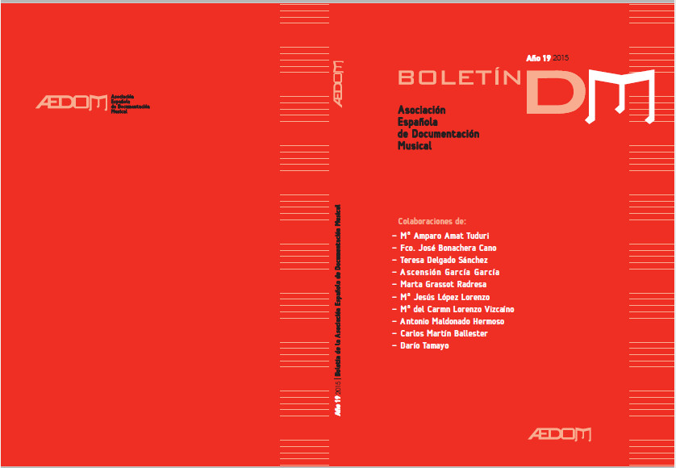

Social media

Aedom continues posting to our Facebook (<https://www.facebook.com/AEDOM/>) and Twitter (<https://twitter.com/AEDOM_IAML>) accounts. We have 317 Twitter followers and 979 likes in Facebook. In 2015 we strengthened the security of our website by introducing anti-hacker software.

Activities

Aedom is a member of the Spanish Federation of Societies of Archives, Libraries, Documentation and Museology (FESABID); through it we keep in contact with the Spanish librarianship world as well as the main international associations of IFLA, ICA, EBLIDA, and ISO. We usually have one or two annual FESABID meetings; this year FESABID had its General Assembly at Gijón on May 28th. This General Assembly took place during the XIV Jornadas Españolas de Documentación, in which we participated actively.

Our association is also a member of the State Council of the Scenic Arts and Music, which reports to the Ministry of Education, Culture and Sport, and gives advice on various Ministry initiatives. In 2015 the meeting of the State Council took place on December 10th, with our participation.

Seminar on RDA (Resource Description and Access): on April 10th 2015, the National Library of Spain held a working session on RDA which had been called by librarians from public institutions throughout Spain. The seminar was organized as a forum for specialists and not as a public event. Aedom was invited and was represented by member and former vice president Jose Luis Maire Montero.

International activities

At the IAML 2015 conference in New York, Jon Bagüés, director of Eresbil (Archive of Basque Music) and former vice president of IAML, presented our annual report. Jon Bagüés is also Chair of the Outreach Committee of IAML. Other Spanish representatives were also at the conference: the Documentation Centre of Music and Dance of INAEM (Ministry of Culture) presented its "Map of musical heritage in Spain," a work with which Aedom has had much to do. In addition José Carlos Gosálvez, Head of the Department of Music and Audiovisual of the National Library of Spain and former president of Aedom also attended.

Antonia Riquelme-Gómez

Vice President of Aedom, IAML (Spain)