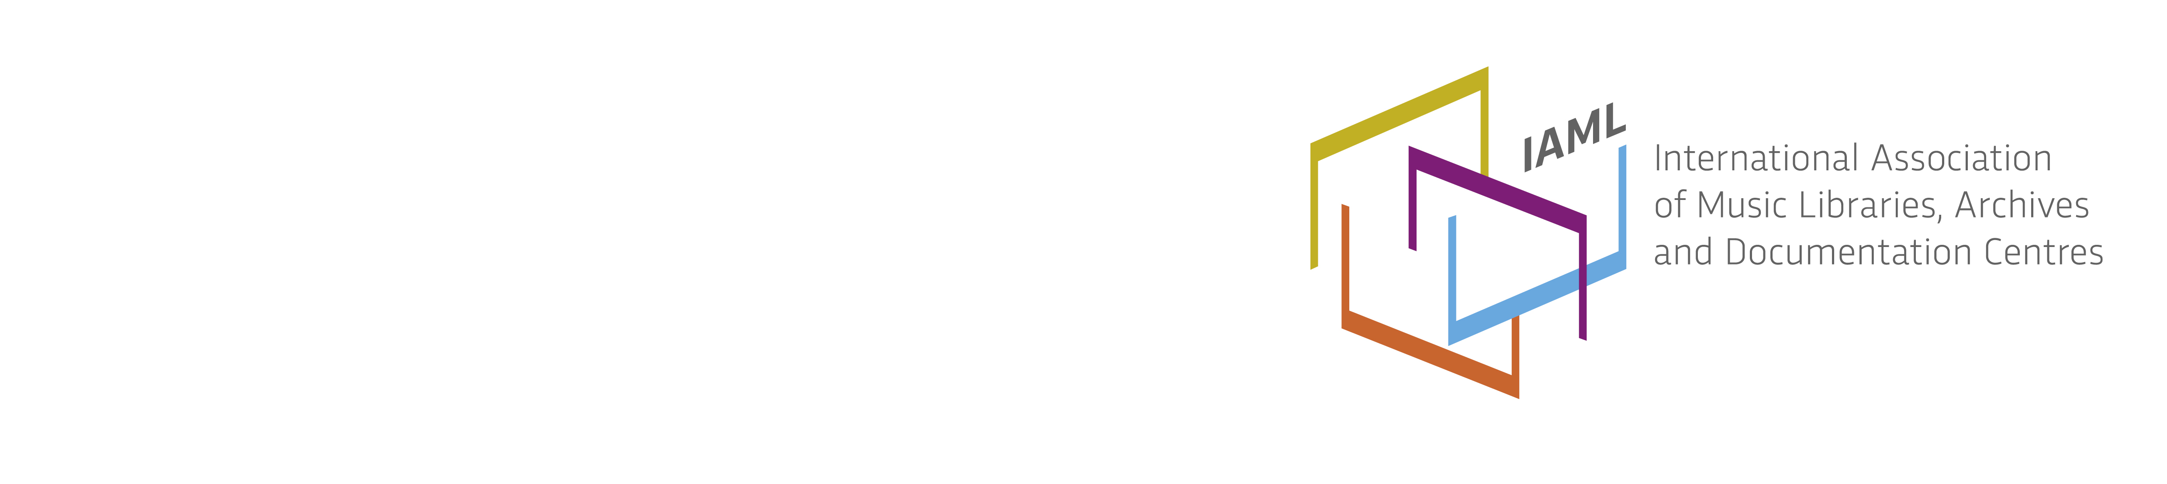
Commission on Service and Training 2016
Chair: Jane Gottlieb, Juilliard School (New York)
Vice-Chair: Kirstin Dougan (University of Illinois at Urbana-Champaign)
Secretary: Anna Pensaert (Cambridge University Library)
The Commission on Service and Training will present two sessions at the 2016 IAML conference in Rome: “Special Libraries, Special Approaches, and the Classroom” (4 July 2016) will include three papers: “Special libraries do special things: a music library’s contribution to the music education community in Greece” by Stephanie Merakos; “Gaming and information literacy for music students: an interactive event in the classroom” by Wilma Abbink, and “Blind students in the music academies: how Stanislaw Moniuszko Academy of Music coped with their studies,” by Pawel Nodzak.
The second session “New Resources, Search Strategies, and Collaborations” (7 July 2016) will include two of the three accepted papers: “Opening East Asian music to the world: the Ewha music database,” by Hyun Kyung CHAE; and “Going beyond boundaries: Collaborations between librarians, teachers, and researchers at the Lucerne University of Applied Sciences and Arts,” by Jörg Müller. Mark McKnight, who was scheduled to present the third paper on this session, is unable to travel to Rome. I expect that we will use the additional time in this session to enlist thoughts from session attendees as to topics that would be of interest for future conferences.
Papers for both sessions in Rome were selected by the commission officers from the “Call for Papers” submission to the Forum on Commissions and Branches, with an eye for those topics most relevant to our mission, “as a forum for the discussion and development of training progammes, not only for those working in music libraries but also their users, as well as for show-casing and promoting those tools and resources through which such training can be delivered.”
Respectfully submitted,
Jane Gottlieb, The Juilliard School

