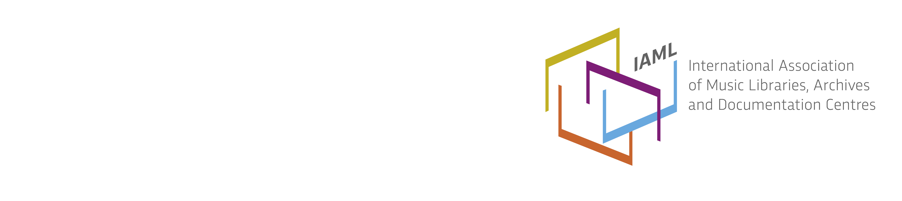

Poland / Polska
Working Meeting of Librarians Cataloguing Music
The 7th Working Meeting of Librarians Cataloguing Music was held in the NUKAT Centre (National Union Catalogue, http://centrum.nukat.edu.pl/en/) in Warsaw on 26-27 October 2015. The Meeting was organized with the cooperation of the NUKAT Centre and the Section of Sound Archives of the Polish Librarians Association (PLA). 60 librarians from 35 institutions participated in this meeting. The 1st Working Meeting took place in 2007, it was devoted to the rules of interpretation for cataloguing printed music. In the next six years themes were extended to cataloguing of sound documents, rules of creating uniform titles and genre/form subject heading for music.
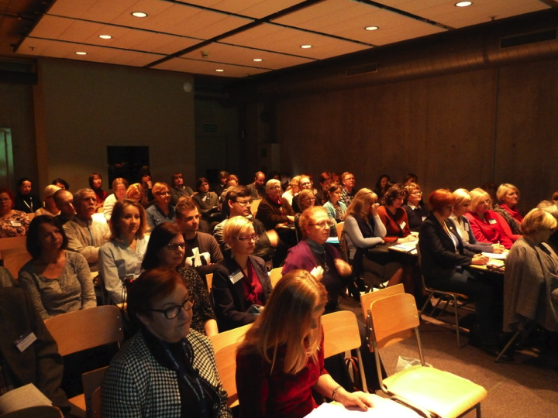
Participants of the 7th Working Meeting of Librarians Cataloguing Music in NUKAT Centre, Warsaw
The programme of the 7th Meeting was divided in three main sessions. The first session, chaired by Ewa Kobierska-Maciuszko, the Director of NUKAT Centre, contained presentations about musical resources in NUKAT Catalogue, functionality of the new interface “Chamo”, the principles of music description in RDA, and selected problems of cataloguing old prints with music using MARC21. The second session (chaired by Stanisław Hrabia, Jagiellonian University, Kraków) was devoted to sound documents: description of 78rpm discs, cataloguing recordings of anthologies, the dilemma associated with cataloguing operas issued on different media like CD or DVD. In the third session (chaired by Marta Walkusz, Music Academy in Gdańsk) administrators from the NUKAT Centre discussed problems concerning audiovisual recording of operas, ballets and concerts, using authority files, practical aspects of daily cooperation with music cataloguers, and benefits in using the new interface “Chamo” for searching music. During each session much time was devoted to discussions, allowing participants to exchange experiences, formulate proposals and ask questions to administrators from NUKAT Centre. The participants expressed the need to continue cooperation through regular webinars and working meetings.
Board meeting in Poznań
On 4 February 2016 the Board of the Music Libraries Section of PLA – Polish National Branch IAML held its mid-year meeting in Poznań at Adam Mickiewicz University (UAM, Uniwersytet Adama Mickiewicza). Choosing Poznań as a place for the meeting enabled a visit to the new Library of the Faculty of History, where the Musicology Section – the former Library of the Department of Musicology at UAM – has its new home.
One of the agenda items was preparation for the Conference “Music Archives and Composers’ Legacies in Polish Libraries” which is planned for 1-2 December 2016 in the Warsaw University Library. Members of the Board expressed their sincere thanks to Hanna Nizińska (the Head of Musicology Section) and Liliana Bether for organizing the visit and warm welcome.
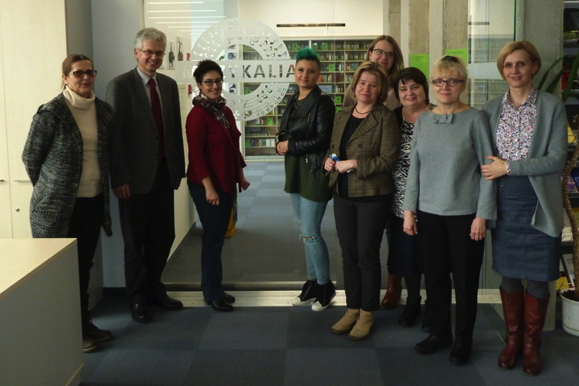
The Board Members of the Polish National Branch of IAML in Poznań
RISM
RISM in Poland is represented by several working groups in Warsaw (Polskie Centrum RISM in Biblioteka Narodowa; Biblioteka Uniwersytecka, Biblioteka Narodowego Instytutu Fryderyka Chopina), Wrocław (Uniwersytet Wrocławski, Biblioteka Uniwersytecka), and Poznań (Uniwersytet Adama Mickiewicza).
The activities of Polskie Centrum RISM in Bibliteka Narodowa and Biblioteka Uniwersytecka in Warsaw included cataloguing of music manuscripts in Kallisto, holding lectures and workshops for musicology students, and providing assistance in searching music resources for students and scholars, as well as presenting papers at national and international conferences.
Sonia Wronkowska from Polskie Centrum RISM in Biblioteka Narodowa in cooperation with Guido Kraus from RISM Central Editorial Office organized an open training session “Introduction to Kallisto” which took place on 3-4 February 2016. During the seminar 5 reports were presented by: Sonia Wronkowska “Polish RISM Centre in The National Library of Poland”, Dr Hab. Magdalena Walter-Mazur “RISM working group in Poznań”, Grzegorz Joachimiak “RISM working group in Wrocław”, Katarzyna Spurgjasz “RISM working group in The Warsaw University Library” and Guido Kraus “RISM Central Office”.
Two projects are being carried out and funded by the “National Program for Humanities Development” of the Ministry of Sciences and Higher Education in the years 2012–2016:
- “The cultural legacy of the monasteries dissolved in the former Polish Commonwealth and in Silesia during 18th and 19th c.: The fate, importance, and inventory” [“Dziedzictwo kulturowe po klasztorach skasowanych na ziemiach dawnej Rzeczypospolitej oraz na Śląsku w XVIII i XIX w.: losy, znaczenie, inwentaryzacja”; project no. 11H 11 021280]. The participants are working groups at the Warsaw University Library, Uniwersytet Wrocławski, and Uniwersytet Adama Mickiewicza. The descriptions of musical manuscripts are available in the RISM database and on the Project website at: http://pw.kasaty.pl/.
- “Musical collections from the sacred and secular centres in Silesia in the context of the musical culture of Central Europe. Cataloguing of preserved sources” [Kolekcje dawnych muzykaliów z ośrodków religijnych i świeckich na Śląsku w kontekście kultury muzycznej Europy Środkowej. Katalogowanie zachowanych źródeł; project no. 11H 11 014980]. The project is led by the group at the Uniwersytet Wrocławski.
Polish music periodicals in digital libraries
The project “Polish music periodicals in digital libraries” [“Polskie czasopisma muzyczne w bibliotekach cyfrowych”] is being continued. The goal of the project is to coordinate digitization of Polish music periodicals published up to 1950 and to gather information about digitized titles. The current results of the project are available on the Polish IAML website at: http://www.iaml.pl/czasopisma/tabela.htm.
Reports
- 2015 IAML/IMS Congress, New York City, 21-26 June. Ewa Hauptman-Fischer, „Konferencje. IAML w Nowym Jorku”, BUWlog. Entry posted August 13, 2015. http://buwlog.uw.edu.pl/iaml-w-nowym-jorku (accessed June 5, 2016).
- 7th Working Meeting of Librarians Cataloguing Music, Warsaw, 26-27 October 2015. Stanisław Hrabia, „VII Spotkanie Robocze Bibliotekarzy Katalogujących Muzykalia”, Tytuł Ujednolicony 1(18) (2016): 7-8. http://kwartalnik.nukat.edu.pl/tytul-ujednolicony-nr-1182016/ (accessed June 5, 2016).
Membership, the Board and social media
The Polish National Branch has 18 members (15 institutional and 3 individual).
The Executive Board: Stanisław Hrabia (Uniwersytet Jagielloński, Kraków) – President, Iwona Bias (Biblioteka Główna Akademii Muzycznej im. Karola Szymanowskiego w Katowicach) and Jolanta Byczkowska-Sztaba (Biblioteka Narodowa, Warszawa) – Vice Presidents, Karolina Skalska (Biblioteka Narodowa, Warszawa) – Secretary. Other Board members are: Hanna Bias (Biblioteka Główna Akademii Muzycznej im. Karola Szymanowskiego w Katowicach), Ewa Hauptman-Fischer (Biblioteka Uniwersytecka w Warszawie, Gabinet Zbiorów Muzycznych), Ewa Kozłowska (Biblioteka Publiczna m.st. Warszawy, Dział Sztuki i Rzemiosł Artystycznych), Anna Michalska (Biblioteka Główna Akademii Muzycznej im. Stanisław Moniuszki w Gdańsku), Hanna Nizińska (Biblioteka Katedry Muzykologii Uniwersytetu Adama Mickiewicza w Poznaniu), Magdalena Wiącek (Biblioteka Główna Akademii Muzycznej im. Karola Lipińskiego we Wrocławiu), and Andrzej Spóz, Biblioteka, Muzeum i Archiwum Warszawskiego Towarzystwa Muzycznego im. Stanisława Moniuszki), Honorary Board Member.
The Polish National Branch of IAML has its fanpage on Facebook https://www.facebook.com/IAMLPL and the website http://www.iaml.pl/.
Stanisław Hrabia
President, IAML (Poland)

