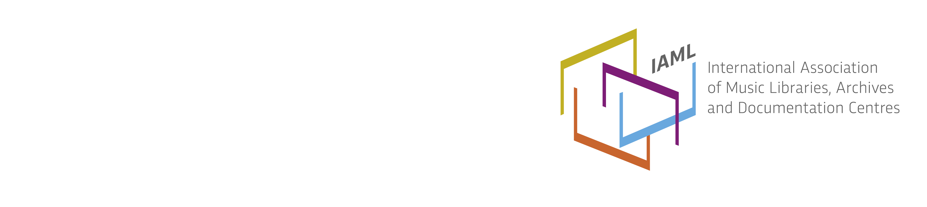

Italy / Italia, Report 2016
At the end of 2015, the Italian branch had 107 members (39 individual and 68 institutional).
The annual assembly was held on October 16th in Rome. The Assembly elected the new Board for the next three years: Tiziana Grande (President), Patrizia Florio (Vice-President), Stefania Gitto (Secretary), Federica Biancheri (Treasurer). The Assembly also voted Agostina Laterza as auditor and Paola Gibbin as deputy-auditor. During the Assembly the new President of the Italian branch thanked Federica Riva and the outgoing Board for the work done in the last three years: she vowed to continue the projects already underway, especially co-operating with public Institutions such as ICCU, the Central Italian Institute for the Library Catalogue.
The 21. IAML-Italia Annual Study Meeting took place on 15-16 October 2015 in Rome at the seat of the national cataloguing agency, ICCU; it aimed to be an opportunity to exchange information and competencies between music librarians and their colleagues working at ICCU and in other central institutes of the Ministry of Culture. The meeting was introduced by Simonetta Buttò, recently nominated head of the Institute; it included: 1) a workshop, coordinated by Patrizia Martini and Federica Riva in cooperation with Massimo Gentili-Tedeschi; 2) a roundtable; 3) the annual assembly of the branch.
The workshop focused on the Uniform Title and its treatment in the national SBN catalogue, rich with more than 425.000 music uniform titles. Three working groups discussed, respectively,
- the application of the new national rules, also in relationship to Unimarc;
- the merging of the National Sound Archives ICBSA (Istituto per I Beni Sonori e Audiovisivi) catalogue into SBN (1.668.926 records cataloguing 300.000 documents, mainly sound recordings);
- the evolution of the SBN Opac.
At the round table, Maria Antonella Fusco (Istituto centrale per la grafica) and Mauro Tosti Croce (Istituto centrale per gli archivi) gave an overview of activities on music promoted by their institutes.
Early in 2016, IAML-Italia re-established some already existing Working Groups on the following topics:
- Setting up a questionnaire for the evaluation of the role of libraries in their institutions;
- Opportunities offered by the Erasmus EU programme for Higher Education Music Institutions library staff;
- Cooperation with ICCU to discuss together the evolution of the SBN Opac.
As a common wish, a cooperation agreement between IAML-Italia and ICCU was signed by IAML Italia president and the head of ICCU on 5 May 2016.
We have been busy organizing the Rome IAML Conference that will take place on 3-8 July 2016, and we are all excited and eager to host our colleagues from all over the world. The scientific program put together by the Forum of Commissions seems very interesting and many people from several countries have already registered as delegates. The social programme will be very intensive too and three concerts, a wide range of excursions and some other surprises will be ready for the attendees.
Finally we have to thank all the staff of the Accademia Nazionale di Santa Cecilia, in particular the head of its multimedia library Annalisa Bini, for the hard work they have done in preparing for the conference. A big thank you goes also to the whole IAML Board for its active collaboration in the organization of the conference.
Tiziana Grande
President IAML Italia

