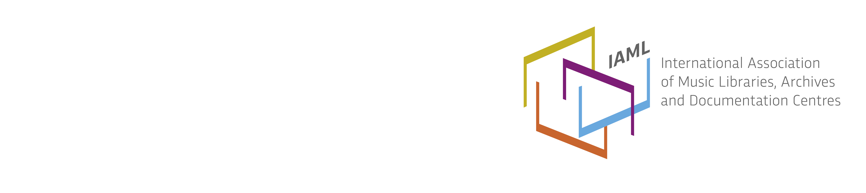
Denmark/Danmark, report 2016
DMBF – Dansk Musikbiblioteksforening – Dansk sektion af IAML = Danish Music Library Society – Danish section of IAML
The Board and membership
National Board/Committee members:
Emilie Wieth-Knudsen, Lyngby-Taarbæk Public Libraries, President
Musse Magnussen Svare, Library of the Royal Danish Academy of Music, Vice President
Helene Olsen, Copenhagen Public Libraries, Treasurer
Øjvind Harkamp, Albertslund Music Library, Secretary
Claus Teglgaard Madsen, Odense Music Library, Webmaster
Karen Vestergaard, Køge Public Libraries
Anne Helle Jespersen, University Library of Southern Denmark, Odense, Music Department
Board meetings during the year 2015/2016 since last congress: (November 17th 2015, January 19th 2016, April 11th 2016, May 30th 2016)
Annual Meeting: Thursday the March 10th, in Copenhagen at The Royal Danish Academy of Music including guided tour at The Music Museum, National Museum of Denmark.
Number of members (December 31st 2015) : Individual: 31, Institutional: 66
New name for the Danish section of IAML
The annual meeting decided to turn back to the society’s previous name and purpose taking out the task of also taking care of librarians working with other media types such as movies and games. Thus the sentence “Society for Music and Media in Libraries” was changed back to “Danish Music Library Society”
Discussions about a new national strategy for access to music in public libraries and the huge scrapping of library materials and (music) collections
Music was not selected as a focus area for the year 2016 at the Danish Digital Library (DDL) strategy day June 8th – 2015 as we had hoped. DDL called the music community to contribute a more coherent vision of what we want. DMBF's board decided to formulate a response to the DDL, where we would attempt to clear up misconceptions about the contents of Bibzoom (the Danish public libraries digital music service). At the strategy day it became evident that Bibzoom is perceived primarily as a streaming service, although it is so much more. DMBF took this opportunity to discuss this and other problems for music libraries – e.g. regarding access to digital sheet music and the widespread scrapping of music collections which is taking place in Danish libraries these days because of low budgets. This discussion resulted in a letter to the DDL, which was sent in December 2015, and an article in the library magazine “Perspektiv”. The article was quoted afterwards elsewhere in the Danish press and on social media. It also resulted in an interview with DMBF president Emilie Wieth-Knudsen in Perspektiv February 2016.
Read the interview and the article here: http://bf.dk/FagmagasinetPerspektiv/~/media/Bibliotekspressen/bladet/2016/2/perspektiv 2-2016.pdf
For information on DDL: http://www.danskernesdigitalebibliotek.dk/english/
SPOT Music Library Conference 2016: New ways for music promotion in libraries?
The SPOT Festival in Aarhus organized in cooperation with Bibzoom, DMBF - Society for Music and Media in libraries, MUFA - Music Librarians Group and Danish Union of Librarians a nationwide music library conference. Here we created space for knowledge sharing among music librarians from across the country and had the opportunity to hear some of the new and most promising names from the Danish music scene. The conference was for all who work with or just have an interest in music and its promotion in libraries - and for all music-lovers.
The theme of the conference was: New ways for music promotion in libraries? It took place on Friday, April 29th, 2016 from 10:00 to 17:00 at Radisson Blu Scandinavia Hotel, Aarhus.
The conference was very inspiring.
For many years the SPOT Festival has been Scandinavia’s most important rendezvous for the Danish and international music industry. Musically, with a wide selection of export-minded and trendsetting acts – and industry-wide, with in-demand networking activities and an ambitious conference programme.
Genre-wide, music, film & interactive have in recent years become more intertwined with new and exciting projects, business models, and sales channels opening up. This trend is an excellent opportunity for the music industry – and for the other industries.
Read more here: http://bf.dk/spot
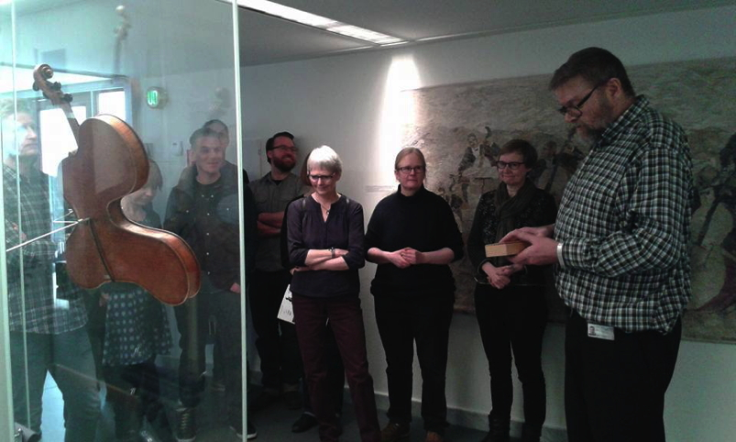
Excited Danish music librarians at the guided tour in the Danish Music Museum before the annual meeting in March 2016. Svend Christiansen talks about the acoustics concerning the rare instrument Violino Arpa.
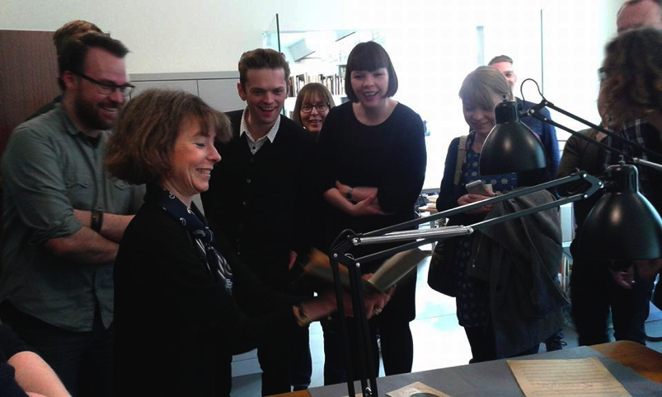
Excited Danish music librarians at the guided tour in the Danish Music Museum before the annual meeting in March 2016. Librarian Marie Martens shows an old book with the drawing of W. A. Mozart’s ear compared to a “normal” ear.
Musse Magnussen Svare,
Vice President

