
Australia report 2016

Membership and Member Updates
Australian membership in 2016 stands at 24 personal members and 16 institutional members. Although we gained 4 personal memberships in 2016, we lost 5 institutional memberships. At least two universities declined to renew membership due to now being able to access Fontes online as part of a package via Project Muse.
Annual General Meeting
The Annual General Meeting was held Friday, 2nd October 2015 at the Australian Institute of Music, Surry Hills, New South Wales, with 23 members in attendance and four apologies.
The Australian executive committee members are:
- President – Linda Papa (The University of Western Australia)
- Vice President – Jacqueline Waylen (Monash University)
- Georgina Binns (University of Melbourne)
- Secretary – Ryan Weymouth (Queensland Conservatorium, Griffith University)
- Treasurer – Denise Tobin (The University of Adelaide)
- Communications Officer – Lisa Mackie (National Library of Australia)
Executive committee meetings were held as email correspondence throughout the year (our committee members live in different states that span the continent of Australia).
Activities
IAML Australia annual national conference “Portals & Pathways” (1-2 October 2015, Sydney)
Australian members and colleagues gathered together in Sydney for our annual conference, jointly hosted by the Australian Music Centre (lead by Judith Foster), and the Australian Institute of Music (lead by Julia Child). 54 registrations were received.
Reflecting the conference title, the program richly illustrated how our colleagues were creating and curating portals to support the needs of our diverse music communities, and the pathways to enable access and inspire use and discovery of resources. Program highlights included the following presentations:
- Copyright issues for Tertiary libraries – presented by Liz Stanton (Manager Key Accounts, APRA AMCOS), many questions were raised and clarified.
- Using Research Skill Development framework in library research workshops for music students – presented by Jackie Waylen (Monash University)
- Western Australian New Music Archive: 1970 – today: Finding, accessing, remembering, performing – presented by composer and academic Dr Cat Hope (Western Australian Academy of Performing Arts, Edith Cowan University). Cat Hope (who leads the collaborative project with Edith Cowan University, the State Library of Western Australia, ABC Classic FM, National Library of Australia and Tura New Music) described the project accomplishments, and future challenges for sustainability and funding.
- Flowers of War: Activating War’s Forgotten Music – presented by Chris Latham (ANZAC Centenary Fellow and Artistic Director)
- Moving to the Cloud: Australian Music Centre’s digitisation project – presented by Judith Foster (Music Resources Manager, Australian Music Centre)
- Music for the nation: Programming the ABC Radio – presented by Katrena Mitchell (Coordinator, Sound & Reference Library, ABC Melbourne), providing a ‘day in the life’ glimpse at the tasks, tools, timelines and knowledge required of a librarian of an esteemed national broadcaster.
- National Library of Australia Updates: the latest on RDA, legal deposit, Trove and more – presented by Nikki White (Senior Librarian, Music Acquisitions & Cataloguing Unit, National Library of Australia)
- Getting to know the score: basic music reference for non-specialists (held concurrently during the 11am-3pm presentations) – presented by Julia Child and Anna Shelmerdine (Australian Institute of Music)
- Composing against the Tide: Early 20th Century Australian women composers and their piano music – presented by musician and academic Dr Jeanell Carrigan (Sydney Conservatorium of Music)
- Discovering the unknown: in search of unpublished works in European archives – presented by musician and academic Dr Kirill Monorosi (Australian Institute of Music)
- Tour of Symphony Services International, Darlinghurst – hosted by Vi King Lim (Library Manager, Symphony Services International), revealing that they are more than a hiring and brokering consultancy service for orchestras, they have established a high quality publishing arm, Goodear Editions, for orchestral performance parts.
Select conference papers are available at http://www.iamlaustralia.org.au/category/2015-conference-papers.
IAML Australia annual national conference 2016
Queensland members have been busy preparing for the next national conference. The IAML Australia conference 2016 has been launched “Local History, Local Music” (29-30 September 2016, Brisbane) #iamlbris16. Details are available at http://www.iamlaustralia.org.au/event/15-new-event.
In other activities, the NSW Network is very busy socially with meet ups every couple of weeks.
Communication and web presence
The Australian branch website is at http://www.iamlaustralia.org.au. Our monthly newsletter subscriber base continues to steadily grow, as well as our Twitter profile (@IAMLAustralia), both of which are expertly maintained by our Communication Officer, Lisa Mackie. The Queensland conference committee has been actively engaging in the social media space (#iamlbris16).
Education
Our ‘Getting to know the score: basic music reference for non-specialists’ workshop is now a regular event in our annual conference program. Twenty people participated in 2015. The workshop was marketed to public libraries which, along with a “meet and greet” session held earlier in the year by committee members, generated increased interest in the workshop and the conference in general. Slides from the workshop were made freely available on our website directly after the conference. New slides will be posted directly after our conference in September.
Advocacy
Richard Gill, a popular conductor and educator in Australia, agreed to be IAML Australia patron in October. He was invited to be patron due to his passionate and exuberant advocacy for music education and music making.
Collections
The National Library of Australia received several important collections, most notably some more of the Richard Bonynge collection of conductor scores (which included some mid-19th century songs published in Sydney) and the Kogarah Concert Band collection (this band is the oldest continuing band of this sort in Australia).
An important acquisition by the National Library of Australia is the George H. Clutsam Archive, which was bought in December at auction from Sotheby’s in London. This consists of over 50 music manuscripts of this Australian composer living and working in England in the first half of the 20th century and includes songs, theatre and film music as well as more “serious” works. This has now been fully catalogued.
In 2014, the Rare Music collection at the Sydney Conservatorium of Music was affected by a fire. Luckily, nothing was permanently damaged but the collection remained inaccessible to students and staff. In May 2016, the collection was moved to the Fisher Library at the University of Sydney and an exhibition was opened to celebrate the collection. "Striking Chords" exhibition will be open till end of November 2016. (More information is at http://sydney.edu.au/news-opinion/news/2016/05/23/rare-music-collection-on-display-at-university.html.)
Project – National Library of Australia
In August 2015, the provisions of the Copyright Act of 1968 for legal deposit were extended to include e-publications. In February this year the extension of legal deposit to born digital items was implemented. The National Library has set up a portal on its website for the new edeposit service (https://www.nla.gov.au/edeposit/). This allows publishers to upload their digital publications directly though at the moment it only has forms for Books and for Serials. Forms and separate buttons are being developed for Music (and also Maps). Currently digital music scores come in via the Book deposit portal, which means the resulting catalogue records generated by the digital collection management system (Banjo) have to be edited to turn them into music records. Also being worked on is the delivery system for this born digital material.
The National Library migrated 13,800 digitised music items from the old digital management system to the new one. They now display far better and have better metadata attached. In addition, a project to digitise all pre-1939 music scores (that are not still in copyright) was completed.
Project – Australian Music Centre
The Australian Music Centre is celebrating 40 years during 2016. Work is continuing on the digital repository. There are now over 26,000 works documented on the Centre’s website, covering contemporary classical, improvised jazz, experimental music and sound art created by Australian artists. The Digital Score Library continues to grow, with approx. 9800 scores available for download for perusal loan in mid-2016. The Centre’s website receives more than 800 visitors each day, including those looking for works for study, performance, broadcast and research.
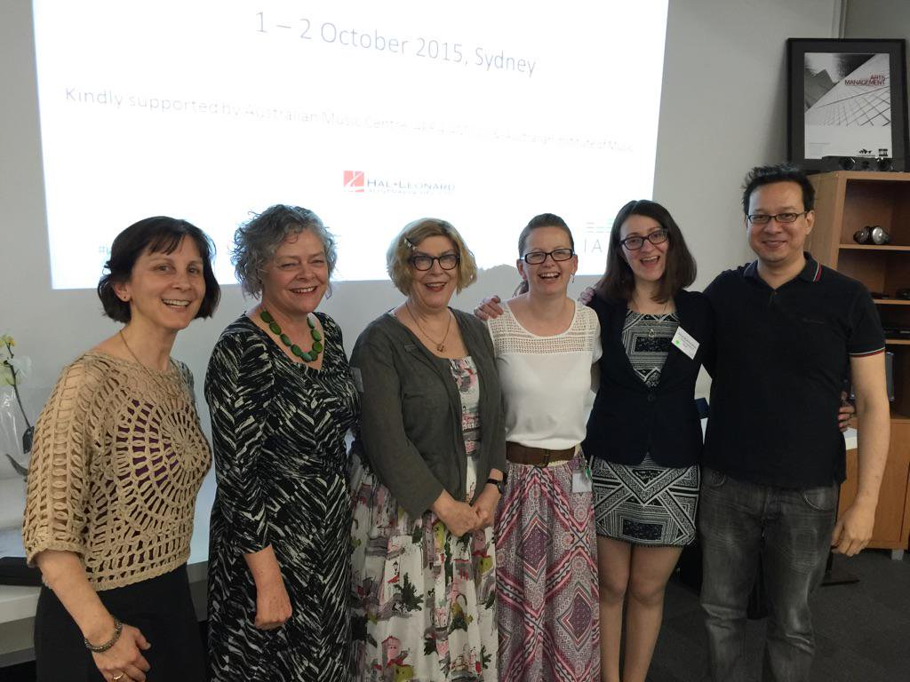
IAML Australia annual national conference 2015 organising committee. From left to right: Marie Chellos, Judith Foster, Margaret Whittaker, Julia Child, Anna Shelmerdine, and James Lee.
Linda Papa
President, IAML (Australia)

