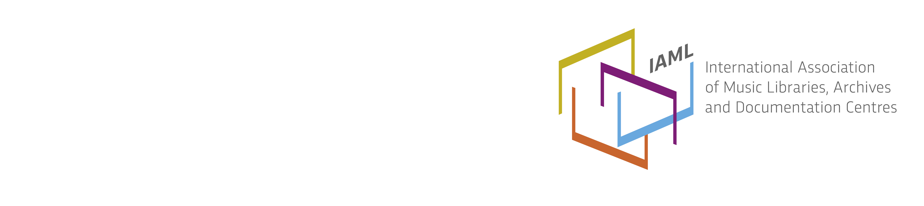
Sweden / Sverige, report 2016
Membership
Until the annual meeting 2016, the Swedish IAML branch had 127 members: 70 individual members, 21 senior or students, and 39 institutions. The board held two full-day meetings between annual meetings.
Website and social media
The Swedish IAML branch has a website http://www.smbf.nu. The Webmaster is Ove Wahlqvist. We also have a Facebook account https://www.facebook.com/groups/16834342191/?fref=ts
Publications
The journal Musikbiblioteksnytt is printed with four issues per year and is also published as a pdf on the website. Gunnel Jönsson and Tobias Danielsson are the new editors from number one of 2016.
Scholarships
Anna-Karin Skansen and Kia Hedell received the association's travel grant to attend the IAML conference in New York. Kia Hedell gave a speech together with Maria Schildt at the conference in New York about The Düben Collection Database Catalogue for printed music and manuscripts. Lena Nettelbladt received Anders Lönn’s travel grant.
Projects
We have an active Swedish RISM committee with five members: Mattias Lundberg, Marina Demina, Kia Hedell, Lars Berglund and Maria Schildt. We have also a Swedish RILM committee with Kerstin Carpvik and Lena Nettelbladt.
Activities
In February the music archive network held a two day conference for folk dance to celebrate the 50th anniversary of the Archive for folk dance. 70 participants listened to 6 lectures and a panel discussion about the future for musical and dance archives.
In November we arranged a day in Stockholm. We visited the Swedish Museum of Performing Arts which will be open in 2017. Then we visited The Nydahl Collection, a private museum with old instruments and music manuscripts. In the afternoon we listened to “The lecture - an anachronistic interview with Bach” performed by the famous Swedish pianist Love Derwinger.
Annual meeting
The annual meeting was held on 14-15 April in the city of Borås and gathered around 19 members. A new boars was elected, consisting of Lena Nettelbladt, (chair), Åse Lugnér (vice chair), Kia Hedell (secretary), Margareta Holdar Davisson (treasurer), Lars Landin, Pia Shekhter, Tobias Danielsson and Staffan Lundmark. The venue on Thursday was Borås public library with Ingrid Boström and Martin Edelfeldt as our hosts. The two days included the following presentations and lectures
- Christina Ekström held a lecture about the The Moravian Church's music aesthetics
- Bengt Andersson talked about the composer Knut Håkansson (1887-1929) who was born in Borås
- Thomas Florentin told us about the Culture School in Borås where children can learn more about music, dance, theater, art, textile and circus.
- We visited Knock on!, a meeting place for parents and young children. The rooms are decorated after a children’s book written and illustrated by Anna-Clara Tidholm.
- In the evening we listened to a concert with “Synthorkestern” with 12 synthesizers and we even performed a jazzy tune as together.
- On Friday we visited Gothenburg Public Library. Boel Enbågen and Niklas Persson were our guides .
- Alfons Karabuda, executive Vice-President of IMC (International Music Council), gave a presentation of Five music rights.
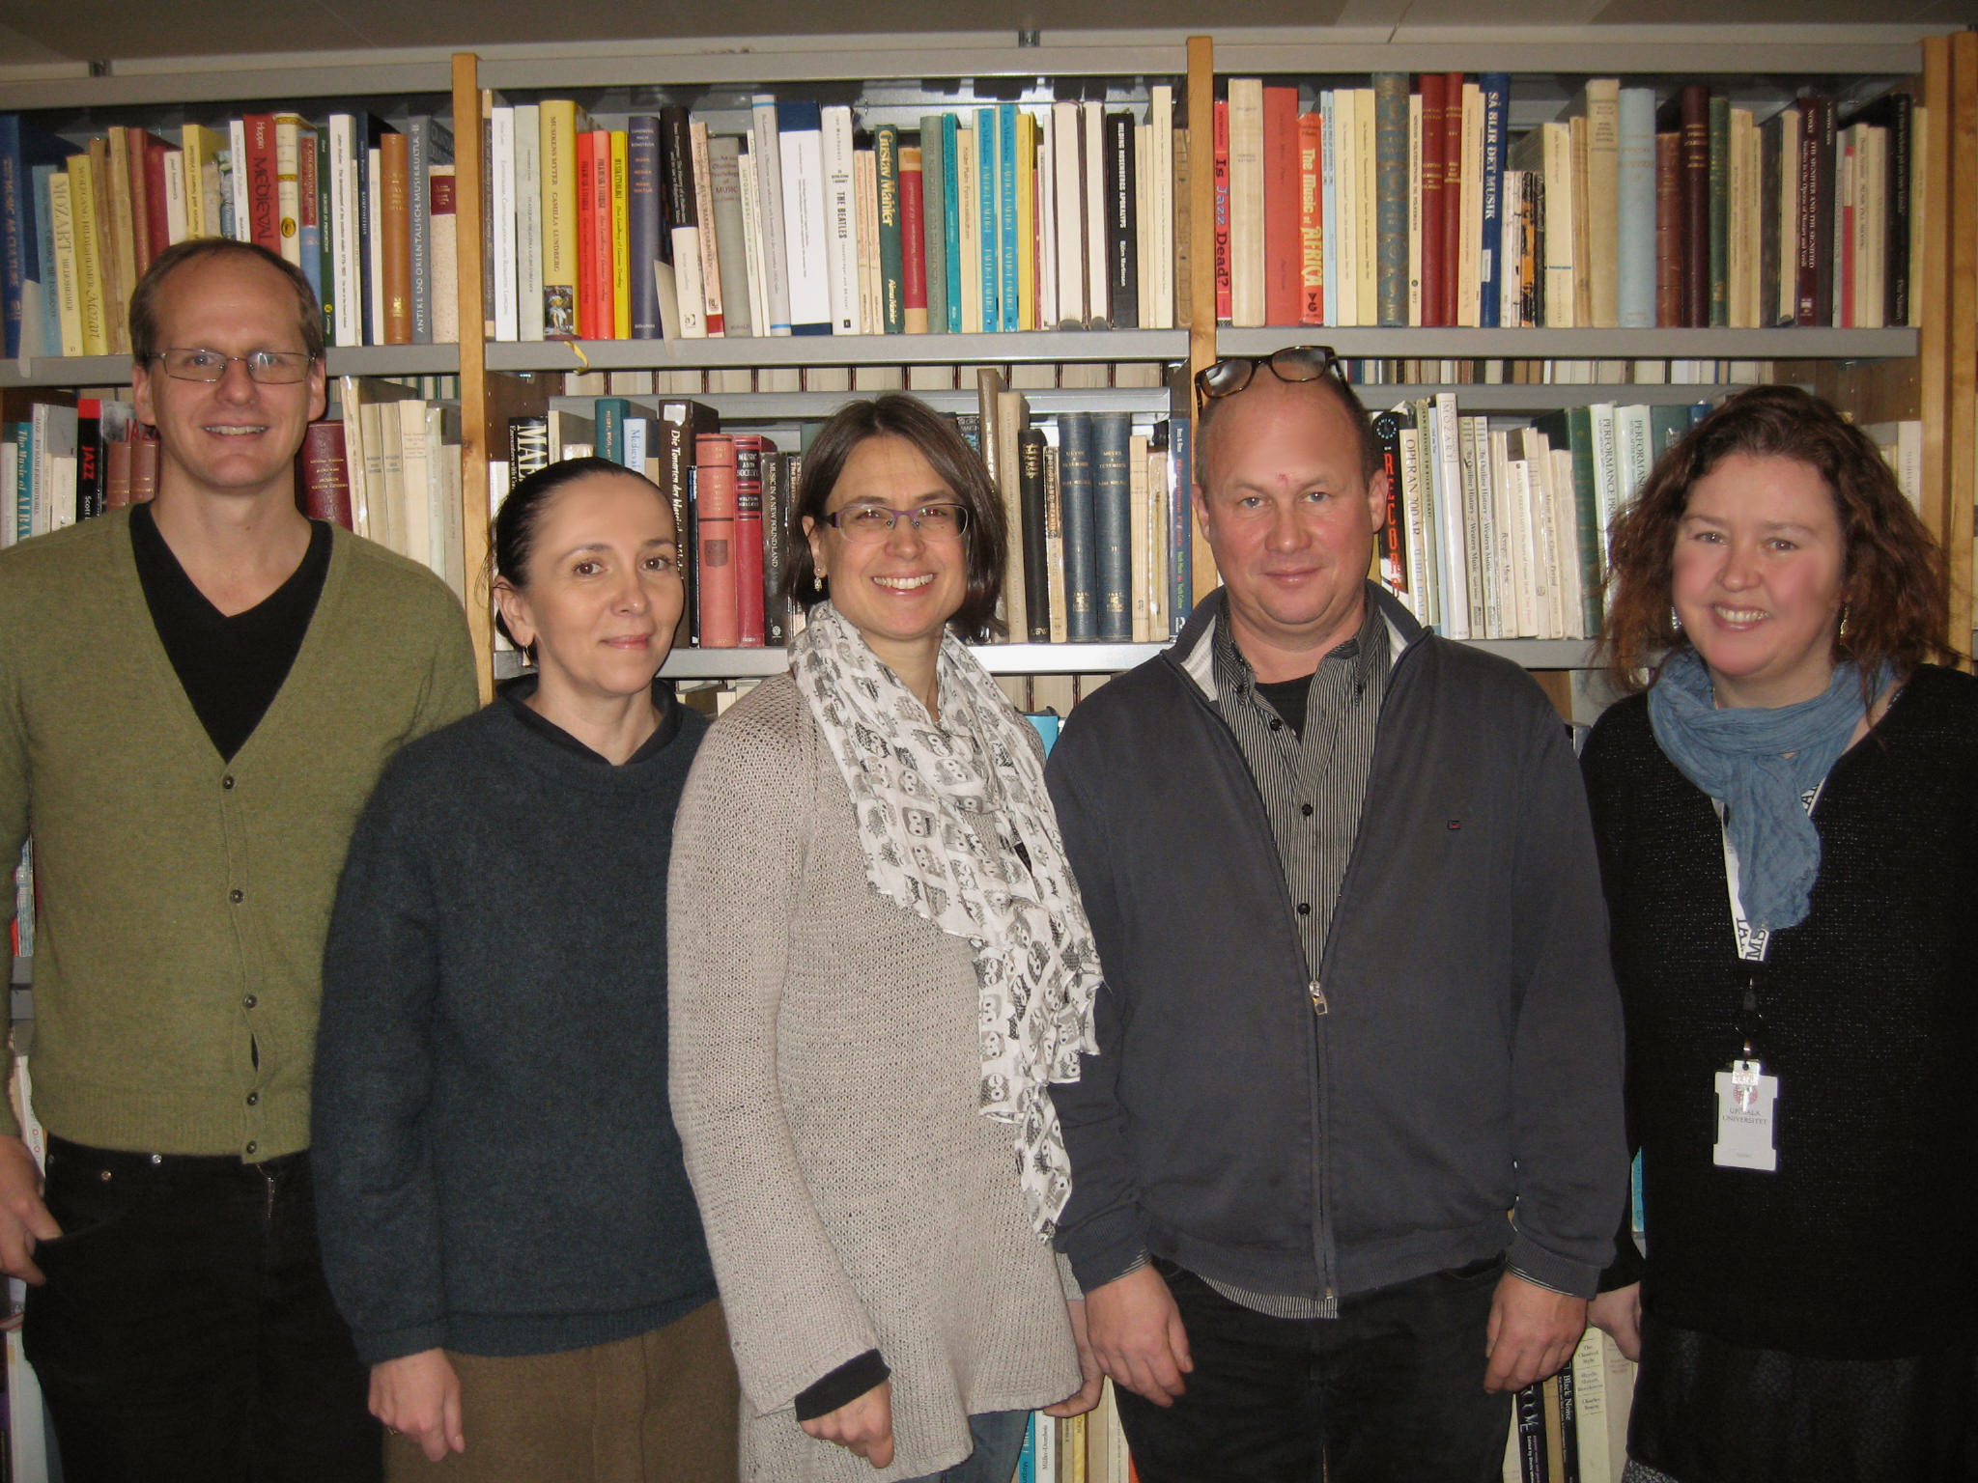 | 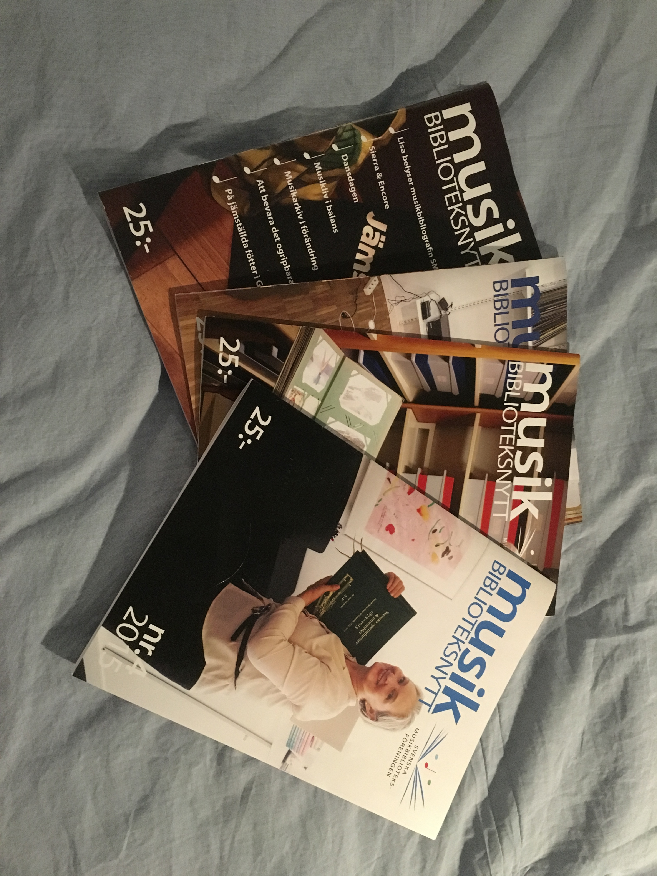
The Swedish RISM Committee. From left to right: Mattias Lundberg, Marina Demina, Kia Hedell, Lars Berglund and Maria Schildt.  Photographer:Karin Eriksson | Musikbiblioteksnytt from 2015, The membership journal of the Swedish IAML Branch.  Photographer: Lena Nettelbladt

Lena Nettelbladt, Bibliotekarie
Stockholms konstnärliga högskola (Stockholm University of the Arts)

